**ABSTRACT**

The recent research work emphasizes on the conservation of energy as well as on the reduction of environmental pollution. This paper introduces an intelligent method for optimizing the street-light-intensity so as to reduce the energy savings the load turn on, reduces the savings of the energy . The working principle is based on the requirement of luminous energy at a particular moment of time. An automatic system is designed using ARDUINO which will switch ON or OFF the street lights at given time and also depending on the intensity of the ambient light. This system also detects the movement of vehicles and interrupts the system to increase the intensity of light on the road.

# INTRODUCTION

# This paper shows the design to detect the vehicle movement on roadways to switch ON just a block of road lights in front of it, and to turn OFF the trailing lights to save energy. During night each one of the lights on the expressway stay ON for the vehicles, yet loss of power is experienced when there is no vehicle movement. This proposed framework satisfactorily works for energy saving. This is accomplished by detecting a vehicle moving towards the street and turns ON a block of street lamps in front of the vehicle. As the vehicle moves forward by, the trailing lamps turn OFF on its own . By doing this, a considerable amount of power is saved. So each of the road lights stay in OFF condition when there are no vehicles on the street. There is another method of operation where instead of turning OFF the lights totally, they stay ON with ten percent of the extreme intensity of the light . As the vehicle approaches, the block of road lamps change to hundred percent intensity and as the vehicle moves forward by, the trailing lights return to ten percent power once more. HID lamps are utilized for metropolitan road lights . The intensity is not governable by any voltage diminishment technique since HID depends on the principle of gas release. White LED based lights are soon supplanting the high intensity discharge lights in road light. Intensity is likewise conceivable by PWM created by the microcontroller. The photodiode and IR LEDs delivers logic signal to microcontroller to turn ON or OFF depending upon the operation . Consequently, this progressively changing from ON/OFF sides in saving a great deal of power. This venture utilizes an 8051- arrangement microcontroller. Proposed venture can be upgraded by utilizing proper sensors for recognizing the unsuccessful road light and afterward delivery a short message service to the control division by means of GSM modem for suitable action.

**OBJECTIVE**

To reduce energy cost and usage with flexible dimming controls; increased pedestrian satisfaction through improved safety measures; lowered repair and maintenance costs with the monitoring software; reduced carbon emissions and light pollution; increased lamp life and shorter response times to outages; improved architectural planning based on real traffic patterns and insights; and increased revenue opportunities, such as leasing poles for digital signage or other services.

**BLOCK DIAGRAM**

V.LCD

NODEMCU

LDR

LIGHT

RELAY

IR

PSU

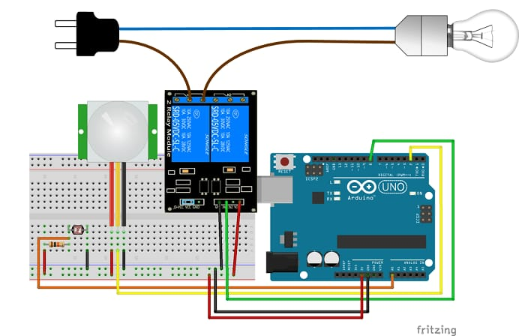

Fig No. 1.1

**INTERNET OF THINGS**

IoT (Internet of Things) is an advanced automation and analytics system which exploits networking, sensing, big data, and artificial intelligence technology to deliver complete systems for a product or service. These systems allow greater transparency, control, and performance when applied to any industry or system.

IoT systems have applications across industries through their unique flexibility and ability to be suitable in any environment. They enhance data collection, automation, operations, and much more through smart devices and powerful enabling technology.

Its distinction without sensors. They act as defining instruments which transform IoT from a standard passive network of devices into an active system capable IoT − Key Features

The most important features of IoT include artificial intelligence, connectivity, sensors, active engagement, and small device use. A brief review of these features is given below −

**AI** − IoT essentially makes virtually anything “smart”, meaning it enhances every aspect of life with the power of data collection, artificial intelligence algorithms, and networks. This can mean something as simple as enhancing your refrigerator and cabinets to detect when milk and your favorite cereal run low, and to then place an order with your preferred grocer.

**Connectivity** − New enabling technologies for networking, and specifically IoT networking, mean networks are no longer exclusively tied to major providers. Networks can exist on a much smaller and cheaper scale while still being practical. IoT creates these small networks between its system devices.

**Sensors** − IoT loses of real-world integration.

**Active Engagement** − Much of today's interaction with connected technology happens through passive engagement. IoT introduces a new paradigm for active content, product, or service engagement.

**Small Devices** − Devices, as predicted, have become smaller, cheaper, and more powerful over time. IoT exploits purpose-built small devices to deliver its precision, scalability, and versatility.

The hardware utilized in IoT systems includes devices for a remote dashboard, devices for control, servers, a routing or bridge device, and sensors. These devices manage key tasks and functions such as system activation, action specifications, security, communication, and detection to support-specific goals and actions.

**IoT Advantages :**

The advantages of IoT span across every area of lifestyle and business. Here is a list of some of the advantages that IoT has to offer –

**Improved Customer Engagement** − Current analytics suffer from blind-spots and significant flaws in accuracy; and as noted, engagement remains passive. IoT completely transforms this to achieve richer and more effective engagement with audiences.

**Technology Optimization** − The same technologies and data which improve the customer experience also improve device use, and aid in more potent improvements to technology. IoT unlocks a world of critical functional and field data.

**Reduced Waste** − IoT makes areas of improvement clear. Current analytics give us superficial insight, but IoT provides real-world information leading to more effective management of resources.

**Enhanced Data Collection** − Modern data collection suffers from its limitations and its design for passive use. IoT breaks it out of those spaces, and places it exactly where humans really want to go to analyze our world. It allows an accurate picture of everything.

**HARDWARE IMPLEMENTATION**

**NODE MCU:**

The Node MCU is an open source firmware and development kit that helps you to prototype your IoT product with ArduinoIDE or in few Lau script lines.  
It includes firmware which runs on the ESP8266 Wi-Fi SoC.And hardware which is based on the ESP-12 module. In this tutorial we explain how to use NodeMCU with Arduino IDE.

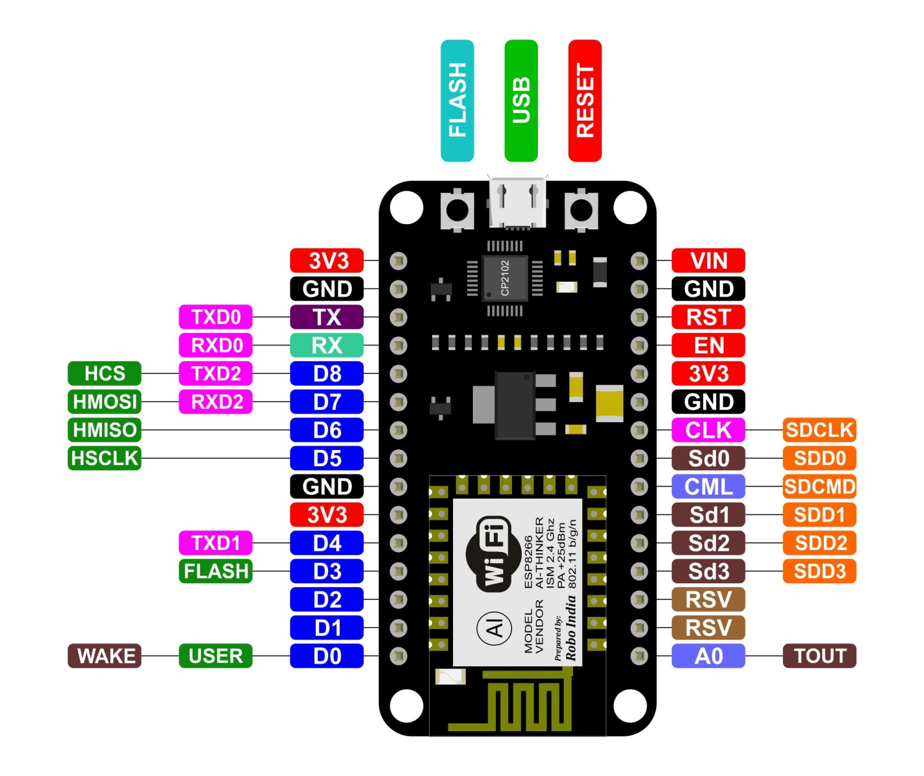

Fig 5.1 Pin Diagram of node MCU

**How to Connect NodeMCU with Arduino IDE**

1. Open up the Arduino IDE.
2. Go to File -> Preferences -> Additional Boards Manager URLs: *http://arduino.esp8266.com/stable/package_esp8266com_index.json* -> click OK
3. Close the IDE and open it up again.
4. Go to Tools -> Board (where you'd select your version of Arduino) -> Boards Manager, find the ESP8266 and click Install. You now should be able to use the ESP8266 as an Arduino. Simply select the NODEMCU 1.0 as your board with Port and you should be ready to code.

Now, with ESP8266 board installed to Arduino IDE, we can program NodeMCU using Arduino IDE directly.

**NODEMCU ESP8266:**

The ESP8266 series, or family, of Wi-Fi chips is produced by Espressif Systems, a fabless semiconductor company operating out of Shanghai, China. The ESP8266 series presently includes the ESP8266EX and ESP8285 chips.

**ESP8266EX** (simply referred to as ESP8266) is a system-on-chip (SoC) which integrates a 32-bit Tensilica microcontroller, standard digital peripheral interfaces, antenna switches, RF balun, power amplifier, low noise receive amplifier, filters and power management modules into a small package. It provides capabilities for 2.4 GHz Wi-Fi (802.11 b/g/n, supporting WPA/WPA2), general-purpose input/output (16 GPIO), Inter-Integrated Circuit (I²C), analog-to-digital conversion (10-bit ADC), Serial Peripheral Interface (SPI), I²S interfaces with DMA (sharing pins with GPIO), UART (on dedicated pins, plus a transmit-only UART can be enabled on GPIO2), and pulse-width modulation (PWM). The processor core, called "L106" by Espressif, is based on Tensilica's Diamond Standard 106Micro 32-bit processor controller core and runs at 80 MHz (or overclocked to 160 MHz). It has a 64 KiB boot ROM, 32 KiB instruction RAM, and 80 KiB user data RAM. (Also, 32  KiB instruction cache RAM and 16 KiB ETS system data RAM.) External flash memory can be accessed through SPI. The silicon chip itself is housed within a 5 mm × 5 mm Quad Flat No-Leads package with 33 connection pads — 8 pads along each side and one large thermal/ground pad in the center.

The ESP8266 is a System on a Chip (SoC), manufactured by the Chinese company [Espressif](https://espressif.com/en/). It consists of a Tensilica L106 32-bit **micro controller** unit (MCU) and a **Wi-Fi transceiver**. It has **11 GPIO pins**\* (General Purpose Input/Output pins), and an **analog input** as well. This means that you can program it like any normal Arduino or other microcontroller. And on top of that, you get Wi-Fi communication, so you can use it to connect to your Wi-Fi network, connect to the Internet, host a web server with real web pages, let your smartphone connect to it, etc ... The possibilities are endless! It's no wonder that this chip has become the most popular IOT device available.

The ESP8266 WiFi Module is a self contained SOC with integrated TCP/IP protocol stack that can give any microcontroller access to your WiFi network. The ESP8266 is capable of either hosting an application or offloading all Wi-Fi networking functions from another application processor. Each ESP8266 module comes pre-programmed with an AT command set firmware, meaning, you can simply hook this up to your Arduino device and get about as much WiFi-ability as a WiFi Shield offers (and that’s just out of the box)! The ESP8266 module is an extremely cost effective board with a huge, and ever growing, community.

This module has a powerful enough on-board processing and storage capability that allows it to be integrated with the sensors and other application specific devices through its GPIOs with minimal development up-front and minimal loading during runtime. Its high degree of on-chip integration allows for minimal external circuitry, including the front-end module, is designed to occupy minimal PCB area. The ESP8266 supports APSD for VoIP applications and Bluetooth co-existanceinterfaces, it contains a self-calibrated RF allowing it to work under all operating conditions, and requires no external RF parts.

## ESP8266 Versions

The ESP8266 comes in a wide variety of versions (as shown in the figure below). The ESP-12E or often called ESP-12E NodeMCU Kit is currently the most practical version, in my opinion.

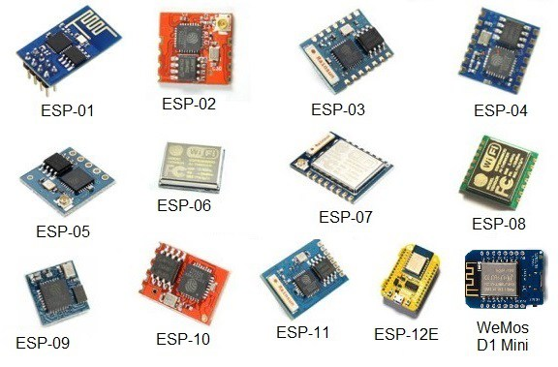

## Fig No. 5.1

## ESP8266 – ESP-01 – V090

In this tutorial, I’m using the ESP8266 (ESP-01) V090, which has two LEDs next to the antenna. You can use the image below as a reference for the pinout.

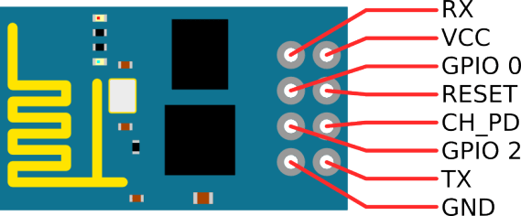

Fig No. 5.2

**Basic AT Commands**

The ESP8266 ESP-01 module has three operation modes:

1. **Access Point (AP)**
2. **Station (STA)**
3. **Both**

In **AP** the Wi-Fi module acts as a Wi-Fi network, or access point (hence the name), allowing other devices to connect to it. This does not mean that you will be able to check your Facebook from your device while the ESP-01 module is operating in the AP mode. It simply establishes a two way communication between the ESP8266 and the device that is connected to it via Wi-Fi.

In **STA** mode, the ESP-01 can connect to an AP such as the Wi-Fi network from your house. This allows any device connected to that network to communicate with the module.

The third mode of operation permits the module to act as both an AP and a STA.

**BLYNK APP:**

Blynk is a Platform with iOS and Android apps to control Arduino, Raspberry Pi and the likes over the Internet.It's a digital dashboard where you can build a graphic interface for your project by simply dragging and dropping widgets.It's really simple to set everything up and you'll [start tinkering](http://www.blynk.cc/getting-started) in less than 5 mins.Blynk  is not tied to some specific board or shield. Instead, it's supporting hardware of your choice. Whether your Arduino or Raspberry Pi  is linked to the Internet over Wi-Fi, Ethernet or this new ESP8266 chip, Blynk will get you online and ready for the **Internet Of Your Things**.

IN ORDER TO USE BLYNK APP YOU WOULD NEED:

* Hardware that works with Blynk. Check the full list of supported hardware
* If your hardware doesn't have connectivity on board, you can use shields like Ethernet, WiFi, GPRS and many others. Blynk also works over Bluetooth and USB

## 1. DOWNLOAD BLYNK APP FOR ANDROID OR IOS

2. GET THE AUTH TOKEN

In order to connect Blynk App and your hardware, you need an Auth Token.

1. Create a new account in Blynk App.
2. Create a New Project. Then choose the board and connection you will use.
3. After the project was created, we will send you Auth Token over email.
4. Check your email inbox and find the **Auth Token**.

 3. INSTALL BLYNK LIBRARY

**Blynk library should be installed manually. Follow the instructions:**

1. Download the latest release .zip file.
2. Unzip it. You will notice that archive contains several folders and several libraries.
3. Copy all these libraries to **your_sketchbook_folder** of **Arduino IDE**. To find the location of **your_sketchbook_folder**,go to top menu in Arduino IDE: File -> Preferences (if you are using Mac OS - go to Arduino → Preferences)

### CREATE A BLYNK ACCOUNTAfter you download the Blynk App, you’ll need to create a New Blynk account. This account is separate from the accounts used for the Blynk Forums, in case you already have one.

### https://docs.blynk.cc/images/register_account.png2. Create a New Project

### https://docs.blynk.cc/images/getting_started/create_project_button.pngAfter you’ve successfully logged into your account, start by creating a new project.

### 3. Choose Your Hardware

Select the hardware model you will use. Check out the list of supported hardware

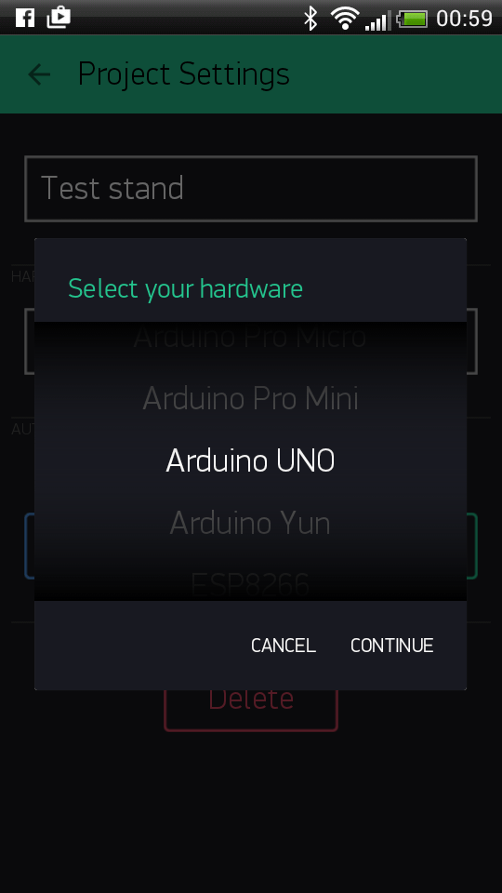

### 4. Auth Token

**Auth Token** is a unique identifier which is needed to connect your hardware to your smartphone. Every new project you create will have its own Auth Token. You’ll get Auth Token automatically on your email after project creation. You can also copy it manually. Click on devices section and selected required device :

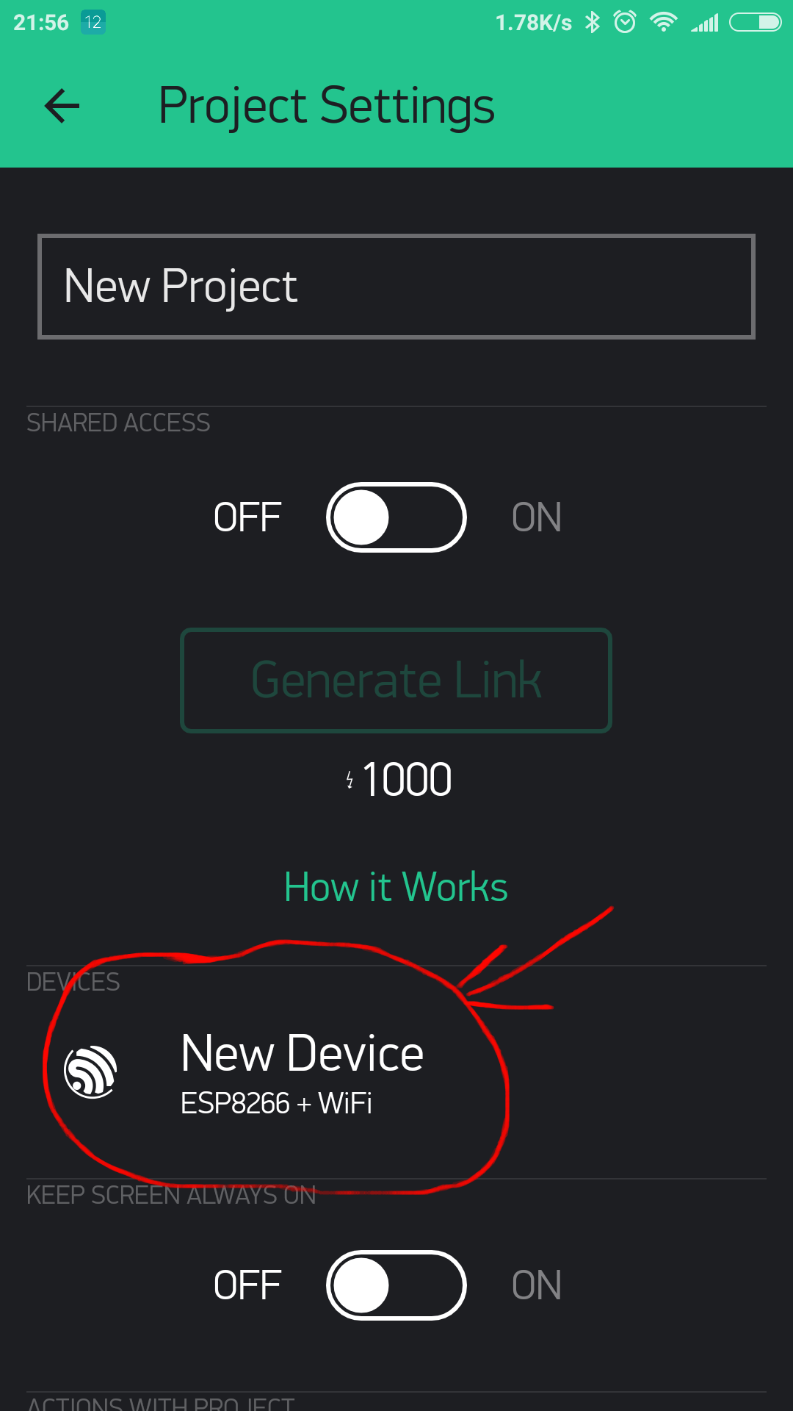

And you’ll see token :

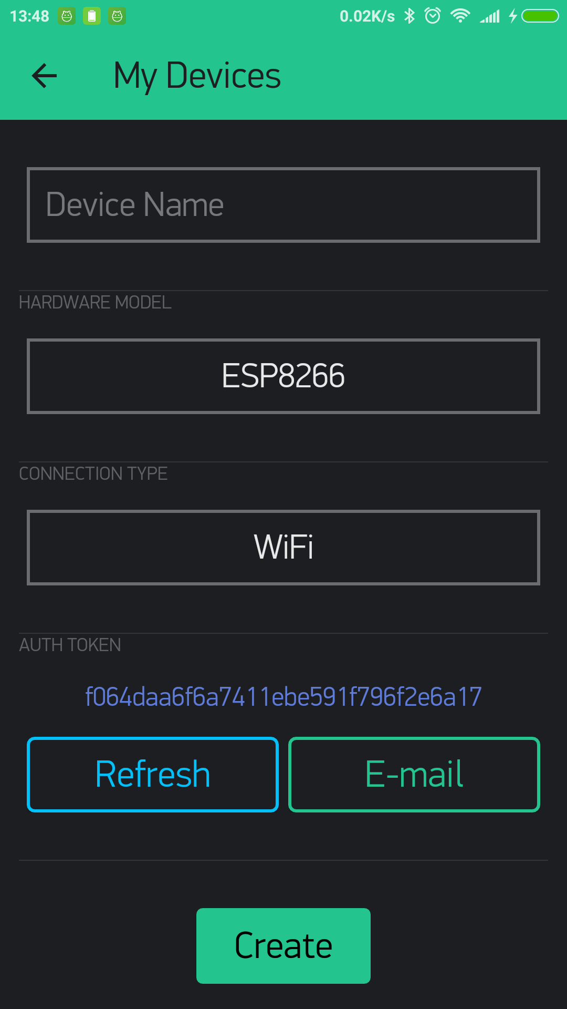

**POWER SUPPLY:**

The power supplies are designed to convert high voltage AC mains electricity to a suitable low voltage supply for electronic circuits and other devices. A **RPS** (**Regulated Power Supply**) is the Power Supply with Rectification, Filtering and Regulation being done on the AC mains to get a Regulated power supply for Microcontroller and for the other devices being interfaced to it.

A power supply can by broken down into a series of blocks, each of which performs a particular function. A d.c power supply which maintains the output voltage constant irrespective of a.c mains fluctuations or load variations is known as “Regulated D.C Power Supply”

For example a 5V regulated power supply system as shown below:

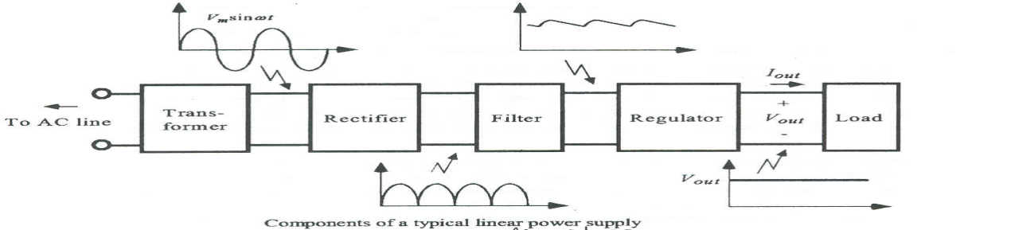

Fig 5.3: Block diagram of power supply

# Transformer:

A transformer is an electrical device which is used to convert electrical power from one Electrical circuit to another without change in frequency.

Transformers convert AC electricity from one voltage to another with little loss of power. Transformers work only with AC and this is one of the reasons why mains electricity is AC. Step-up transformers increase in output voltage, step-down transformers decrease in output voltage. Most power supplies use a step-down transformer to reduce the dangerously high mains voltage to a safer low voltage.

The two lines in the middle of the circuit symbol represent the core. Transformers waste very little power so the power out is (almost) equal to the power in. Note that as voltage is stepped down current is stepped up. The ratio of the number of turns on each coil, called the turn’s ratio, determines the ratio of the voltages. A step-down transformer has a large number of turns on its primary coil which is connected to the high voltage mains supply, and a small number of turns on its secondary coil to give a low output voltage.

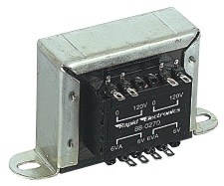

Fig 5.4: Transformer

An Electrical Transformer Turns ratio = Vp / VS = Np/Ns

Power Out= Power InVS X IS=VP XIP

Vp=primary(input)voltage

Np=numberofturnsonprimarycoil  
 Ip  = primary (input) current

**Rectifier:**

A circuit which is used to convert ac to dc is known as RECTIFIER. The process of conversion ac to dc is called “rectification”

**Full wave rectifier:**

Full wave rectifier is available in two ways like center-tapped full-wave rectifier and bridge full-wave rectifier.

**1. Bridge type full wave rectifier:**

The Bridge rectifier is a circuit, which converts an ac voltage to dc voltage using both half cycles of the input ac voltage. The Bridge rectifier circuit is shown in the figure. The circuit has four diodes connected to form a bridge. The ac input voltage is applied to the diagonally opposite ends of the bridge. The load resistance is connected between the other two ends of the bridge.

For the positive half cycle of the input ac voltage, diodes D1 and D3 conduct, whereas diodes D2 and D4 remain in the OFF state. The conducting diodes will be in series with the load resistance RL and hence the load current flows through RL. For the negative half cycle of the input ac voltage, diodes D2 and D4 conduct whereas, D1 and D3 remain OFF.

The conducting diodes D2 and D4 will be in series with the load resistance RL and hence the current flows through RL in the same direction as in the previous half cycle. Thus a bi-directional wave is converted into a unidirectional wave.

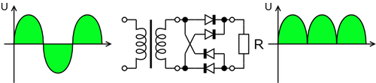

Fig 5.5: bridge type full-wave rectifier

**Filter:**

A Filter is a device which removes the a.c component of rectifier output but allows the dc component to reach the load

**Capacitor Filter:**

We have seen that the ripple content in the rectified output of half wave rectifier is 121%or that of full-wave or bridge rectifier or bridge rectifier is 48% such high percentages of ripples is not acceptable for most of the applications. Ripples can be removed by one of the following methods of filtering.

(a) A capacitor, in parallel to the load, provides an easier by –pass for the ripples voltage though it due to low impedance. At ripple frequency and leave the D.C. to appear at the load.

(b) An inductor, in series with the load, prevents the passage of the ripple current (due to high impedance at ripple frequency) while allowing the d.c (due to low resistance to d.c)

(c)Various combinations of capacitor and inductor, such as L-section filter  section filter, multiple section filter etc. which make use of both the properties mentioned in (a) and (b) above. Two cases of capacitor filter, one applied on half wave rectifier and another with full wave rectifier.

Filtering is performed by a large value electrolytic capacitor connected across the DC supply to act as a reservoir, supplying current to the output when the varying DC voltage from the rectifier is falling. The capacitor charges quickly near the peak of the varying DC, and then discharges as it supplies current to the output. Filtering significantly increases the average DC voltage to almost the peak value (1.4 × RMS value).

To calculate the value of capacitor(C),

C = ¼*√3*f*r*Rl

Where,

f = supply frequency,

r = ripple factor,

Rl = load resistance

**Note**: In our circuit we are using 1000µF hence large value of capacitor is placed to reduce ripples and to improve the DC component.

**Regulator:**

Voltage regulator ICs is available with fixed (typically 5, 12 and 15V) or variable output voltages. The maximum current they can pass also rates them. Negative voltage regulators are available, mainly for use in dual supplies. Most regulators include some automatic protection from excessive current ('overload protection') and overheating ('thermal protection'). Many of the fixed voltage regulators ICs have 3 leads and look like power transistors, such as the 7805 +5V 1A regulator shown on the right.

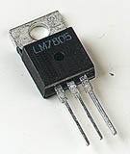

Fig 5.6: A Three Terminal Voltage Regulator

**LDR:**

A **Light Dependent Resistor** (LDR) or a photo [resistor](http://www.electrical4u.com/types-of-resistor-carbon-composition-and-wire-wound-resistor/) is a device whose resistivity is a function of the incident electromagnetic radiation. Hence, they are light sensitive devices. They are also called as photo conductors, photo conductive cells or simply photocells. They are made up of [semiconductor](http://www.electrical4u.com/theory-of-semiconductor/) materials having high resistance. There are many different symbols used to indicate a **LDR**, one of the most commonly used symbol is shown in the figure below. The arrow indicates light falling 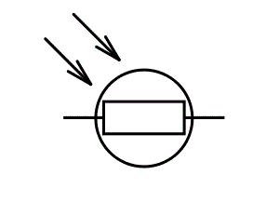

**Working Principle of LDR**

A **light dependent** [**resistor**](http://www.electrical4u.com/types-of-resistor-carbon-composition-and-wire-wound-resistor/) works on the principle of photo conductivity. Photo conductivity is an optical phenomenon in which the materials conductivity (Hence resistivity) reduces when light is absorbed by the material.

When light falls i.e. when the photons fall on the device, the electrons in the valence band of the [semiconductor](http://www.electrical4u.com/theory-of-semiconductor/) material are excited to the conduction band. These photons in the incident light should have energy greater than the band gap of the [semiconductor](http://www.electrical4u.com/theory-of-semiconductor/) material to make the electrons jump from the valence band to the conduction band. Hence when light having enough energy is incident on the device more & more electrons are excited to the conduction band which results in large number of charge carriers. The result of this process is more and more [current](http://www.electrical4u.com/electric-current-and-theory-of-electricity/) starts flowing and hence it is said that the [resistance](http://www.electrical4u.com/electrical-resistance-and-laws-of-resistance/) of the device has decreased.This is the most common **working principle of LDR**

**Characteristics of LDR**

LDR’s are light dependent devices whose [resistance](http://www.electrical4u.com/electrical-resistance-and-laws-of-resistance/) decreases when light falls on them and increases in the dark. When a **light dependent** [**resistor**](http://www.electrical4u.com/types-of-resistor-carbon-composition-and-wire-wound-resistor/) is kept in dark, its resistance is very high. This resistance is called as dark [resistance](http://www.electrical4u.com/electrical-resistance-and-laws-of-resistance/). It can be as high as 1012 Ω. And if the device is allowed to absorb light its [resistance](http://www.electrical4u.com/electrical-resistance-and-laws-of-resistance/) will decrease drastically. If a constant [voltage](http://www.electrical4u.com/voltage-or-electric-potential-difference/) is applied to it and intensity of light is increased the [current](http://www.electrical4u.com/electric-current-and-theory-of-electricity/) starts increasing. Figure below shows [resistance](http://www.electrical4u.com/electrical-resistance-and-laws-of-resistance/) vs. illumination curve for a particular **LDR**.

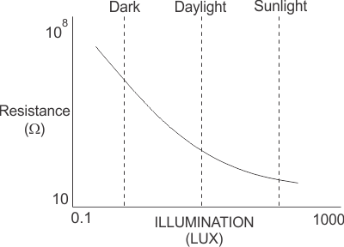

Photocells or LDR’s are non linear devices. There sensitivity varies with the wavelength of light incident on them. Some photocells might not at all response to a certain range of wavelengths. Based on the material used different cells have different spectral response curves.

When light is incident on a photocell it usually takes about 8 to 12ms for the change in [resistance](http://www.electrical4u.com/electrical-resistance-and-laws-of-resistance/) to take place, while it takes seconds for the [resistance](http://www.electrical4u.com/electrical-resistance-and-laws-of-resistance/) to rise back again to its initial value after removal of light. This phenomenon is called as [resistance](http://www.electrical4u.com/electrical-resistance-and-laws-of-resistance/) recovery rate. This property is used in audio compressors. Also, **LDR**’s are less sensitive than photo diodes and photo transistor. (A photo [diode](http://www.electrical4u.com/diode-working-principle-and-types-of-diode/) and a photocell (LDR) are not the same, a photo-diode is a p-n junction [semiconductor](http://www.electrical4u.com/theory-of-semiconductor/) device that converts light to electricity, whereas a photocell is a passive device, there is no p-n junction in this nor it “converts” light to electricity).

**Types of Light Dependent Resistors**:

Based on the materials used they are classified as:

i) Intrinsic photo [resistor](http://www.electrical4u.com/types-of-resistor-carbon-composition-and-wire-wound-resistor/)s (Un doped semiconductor): These are pure [semiconductor](http://www.electrical4u.com/theory-of-semiconductor/) materials such as silicon or germanium. Electrons get excited from valance band to conduction band when photons of enough energy falls on it and number charge carriers increases.

ii) Extrinsic photo [resistor](http://www.electrical4u.com/types-of-resistor-carbon-composition-and-wire-wound-resistor/)s: These are [semiconductor](http://www.electrical4u.com/theory-of-semiconductor/) materials doped with impurities which are called as dopants. Theses dopants create new energy bands above the valence band which are filled with electrons. Hence this reduces the band gap and less energy is required in exciting them. Extrinsic photo [resistor](http://www.electrical4u.com/types-of-resistor-carbon-composition-and-wire-wound-resistor/)s are generally used for long wavelengths.

**Construction of a Photocell**

The structure of a light dependent [resistor](http://www.electrical4u.com/types-of-resistor-carbon-composition-and-wire-wound-resistor/) consists of a light sensitive material which is deposited on an insulating substrate such as ceramic. The material is deposited in zigzag pattern in order to obtain the desired [resistance](http://www.electrical4u.com/electrical-resistance-and-laws-of-resistance/)& power rating. This zigzag area separates the metal deposited areas into two regions. Then the ohmic contacts are made on the either sides of the area. The [resistance](http://www.electrical4u.com/electrical-resistance-and-laws-of-resistance/)s of these contacts should be as less as possible to make sure that the [resistance](http://www.electrical4u.com/electrical-resistance-and-laws-of-resistance/) mainly changes due to the effect of light only. Materials normally used are cadmium sulphide, cadmium selenide, indium antimonide and cadmium sulphonide. The use of lead and cadmium is avoided as they are harmful to the environment.

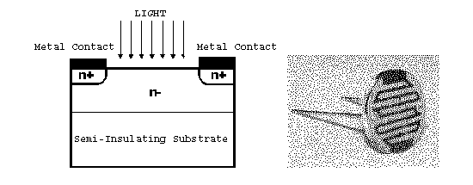

**Applications of LDR**

**LDR**’s have low cost and simple structure. They are often used as light sensors. They are used when there is a need to detect absences or presences of light like in a camera light meter. Used in street lamps, alarm clock, burglar alarm circuits, light intensity meters, for counting the packages moving on a conveyor belt, etc.

There are many applications for Light Dependent Resistors. These include:

### 1.Lighting switch

The most obvious application for an LDR is to automatically turn on a light at certain light level. An example of this could be a street light or a garden light.

### 2.Camera shutter control

LDRs can be used to control the shutter speed on a camera. The LDR would be used the measure the light intensity and the set the camera shutter speed to the appropriate level.

**IR SENSOR:**

IR detectors are little microchips with a photocell that are tuned to listen to infrared light. They are almost always used for remote control detection - every TV and DVD player has one of these in the front to listen for the IR signal from the clicker. Inside the remote control is a matching IR LED, which emits IR pulses to tell the TV to turn on, off or change channels. IR light is not visible to the human eye, which means it takes a little more work to test a setup.

IR detectors are specially filtered for Infrared light, they are not good at detecting visible light. On the other hand, photocells are good at detecting yellow/green visible light, not good at IR light.

IR detectors are digital out - either they detect 38KHz IR signal and output low (0V) or they do not detect any and output high (5V). Photocells act like resistors, the resistance changes depending on how much light they are exposed to.

**RELAY:**

Thus far we have seen a selection of *Input* devices that can be used to detect or “sense” a variety of physical variables and signals and are therefore called **Sensors**. But there are also a variety of electrical and electronic devices which are classed as *Output* devices used to control or operate some external physical process. These output devices are commonly called **Actuators**.Actuators convert an electrical signal into a corresponding physical quantity such as movement, force, sound etc. An actuator is also classed as a transducer because it changes one type of physical quantity into another and is usually activated or operated by a low voltage command signal. Actuators can be classed as either binary or continuous devices based upon the number of stable states their output has.

For example, a relay is a binary actuator as it has two stable states, either energised and latched or de-energised and unlatched, while a motor is a continuous actuator because it can rotate through a full 360o motion. The most common types of actuators or output devices are **Electrical Relays**, **Lights**, **Motors** and **Loudspeakers**.

We saw previously that solenoids can be used to electrically open latches, doors, open or close valves, and in a variety of robotic and mechatronic applications, etc. However, if the solenoid plunger is used to operate one or more sets of electrical contacts, we have a device called a *relay* that is so useful it can be used in an infinite number of different ways

**Electrical Relay Contact Types :**

As well as the standard descriptions of Normally Open, (NO) and Normally Closed, (NC) used to describe how the relays contacts are connected, relay contact arrangements can also be classed by their actions. Electrical relays can be made up of one or more individual switch contacts with each “contact” being referred to as a “pole”. Each one of these contacts or poles can be connected or “*thrown*” together by energizing the relays coil and this gives rise to the description of the contact types as being:

* SPST – Single Pole Single Throw
* SPDT – Single Pole Double Throw
* DPST – Double Pole Single Throw
* DPDT – Double Pole Double Throw

with the action of the contacts being described as “**Make**” (**M**) or “**Break**” (**B**). Then a simple relay with one set of contacts as shown above can have a contact description of:

“Single Pole Double Throw – (Break before Make)”, or SPDT – (B-M)

Examples of just some of the more common diagrams used for electrical relay contact types to identify relays in circuit or schematic diagrams is given below but there are many more possible configurations.

**Electrical Relay Contact Configurations**

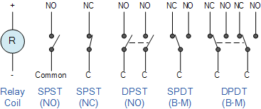

Fig No. 5.7

* Where:
* C is the Common terminal
* NO is the Normally Open contact
* NC is the Normally Closed contact

**Application and Advantages :**

* The street light control circuit can be used in normal roads, highways, express ways etc.
* The project can also be used in parking areas of malls, hotels, industrial lighting, etc.
* If the lighting system implements all LED lights, the cost of the maintenance can be reduced as the life span and durability of LEDs is higher than Neon based lights which are normally used as street lights.
* As the lights are automatically turned ON or OFF, huge amount of energy can be saved.
* This system less costly, less installation and maintenance cost and more efficient as compared to the others system 34 Chapter 7 Limitations and Future Work
* This system can be used for only one way traffic. A highway might be covered by this system on dual system installation on both side.
* The system does not have any automatic fault detector.
* Pole damage detection with the addition of suitable sensor can be implemented.

**WORKING**

Here the LDR sensor is used to detect whether it is daytime or night time. Since LDR sensor generates variable resistance based on the amount of light falling on it, it has to be connected like a potentiometer. One end of the LDR sensor is connected to 5V and other end is connected to fixed resistance which is further connected to ground. NodeMCU has one ADC pin (A0) which is connected to point between fixed resistance and one end of the LDR sensor as shown in the circuit diagram. Since the LDR sensor gives variable resistance therefore variable voltage will be generated at A0 according to the amount of light falling on LDR.

IR sensors are used to detect if someone is crossing the street or not. It detects the obstacle or motion in the surrounding. The transmitter will transmit IR rays which will be reflected back if it falls on some object like person, animal, vehicles, etc. The reflected ray will be received by receiver diode and hence will confirm the presence of object and the corresponding LED will be glowed. This method will save significant amount of electricity as the street light will only turns on if there is someone present in the Street. IR sensor has 3 pins, two of which are VCC and ground and one is output pin. The output of IR sensor gets high if detects presence of some object. This pin is connected to GPIO pin of NodeMCU so whenever the IR sensor detects someone passing through the street it triggers the Street light. In our case one LED will be turned on.

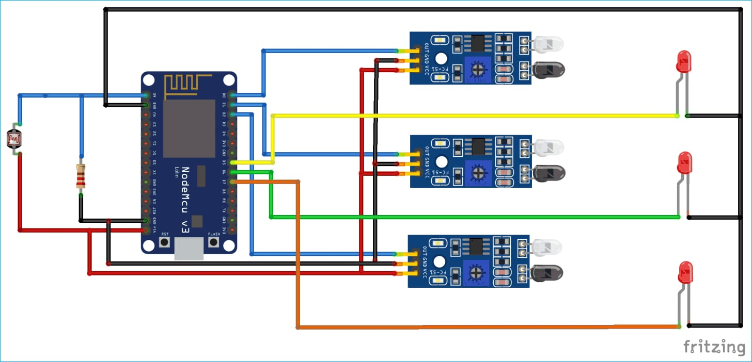

Fig No. 6.1 Circuit diagram

**Conclusion**

By using Smart Street light, one can save surplus amount of energy which is done by replacing sodium vapor lamps by LED and adding an additional feature for security purposes. It prevents unnecessary wastage of electricity, caused due to manual switching of streetlights when it’s not required. It provides an efficient and smart automatic streetlight control system with the help of IR sensors. It can reduce the energy consumption and maintains the cost. The system is versatile, extendable and totally adjustable to user needs.

• The system is now used only for One way traffic in highways.

• Continuous uses of LDR and IR sensors even in day time.

• Not switched on before the sunset. The Smart light system can be further extended to make the current system in two way traffic, making the system more flexible in case of rainy days and introduction of ways to control the lights through GSM based service.

**References**

1. International Journal of Innovative Research in Computer and Communication Engineering (An ISO 3297: 2007 Certified Organization) Website: www.ijircce.com Vol. 5, Issue 3, March 2017 Smart Street Light Using Arduino Uno Microcontroller

2. S. Suganya, R. Sinduja, T. Sowmiya& S. Senthilkumar, Street light glow on detecting vehicle movement using sensor

3. K.Santha Sheela,S.Padmadevi, Survey on Street Lighting System Based On Vehicle Movements

4. Srikanth M, Sudhakar K N,ZigBee Based Remote Control Automatic Street Light System

5. M.Abhishek, Syed ajram shah, K.Chetan, K,Arun Kumar, Design and implementation of traffic flow based street light control system with effective utilization of solar energy, International journal of Science Engineering and Advance Technology, IJSEAT, Vol 3, Issue.

6. [www.chatgpt.com](http://www.chatgpt.com)

7. [www.wikipedia.com](http://www.wikipedia.com)